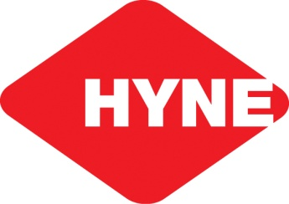

**MCj01994470000[1]Tumbarumba Community Small Grants**

**2018 Application Form**

* Please provide as much information as possible in the spaces allocated
* Please add attachments if further detail or space is required.

**Section 1: Contact Details**

|  |  |
| --- | --- |
| Name of organisation / group: |  |
| Postal Address: |  |
| Contact Person: |  |
| Position of contact person in the organisation / group: |  |
| Business hours telephone: |  |
| Mobile: |  |
| Email: |  |

**Section 2: Project Details**

|  |  |
| --- | --- |
| Project Title: |  |
| How much money are you requesting from the Committee? (please attach quotes if available) |  |

**Section 2: (continued)**

|  |  |  |
| --- | --- | --- |
| **Details** | **Estimated $** | **Quotes /**  **Supporting evidence attached** |
|  | $ | YES / NO |
|  | $ | YES / NO |
|  | $ | YES / NO |
| Total: | $ |  |

|  |  |
| --- | --- |
| Provide brief outline of the project?  How will the project benefit the community? |  |
| What is the timeframe for the project to be completed?  (include major milestones)  (note: Funding allocation to be completed by 30 June 2019) |  |
| Is other funding contributing to the project? Provide details. |  |

**Section 3: Application Declaration**

Please have two members of your organisation complete the details below – one member must be the President (or equivalent) of the organisation.

We declare that we have been authorised by the applicant organisation to prepare and submit this application to the Committee for the 2018 Tumbarumba Community Small Grants Program. We declare that the information included in this application is true and correct and that we will abide by the conditions set out in the 2018 Tumbarumba Community Grant Guidelines which we have read and understood.

**Name**

**Position in Organisation:**

**Contact No.**

**Signature: Date:**

**Name**

**Position in Organisation:**

**Contact No.**

**Signature: Date:**

Completed forms can be posted or delivered (business hours) to the following address:

Tumbarumba Small Grants Committee

C/ Snowy Valleys Council

10 Bridge St

Tumbarumba, NSW 2653

**OR**

Email: mgilbert@snowyvalleys.nsw.gov.au