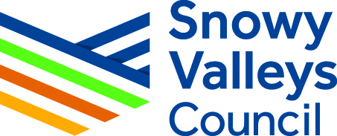

Invitation for Expressions of Interest –
Youth Holiday Programs

Overview and Purpose of this Invitation
Snowy Valleys Council facilitates youth school holiday programs for youth aged 12-24. The aim of the holiday programs is to provide a variety of safe, affordable and rewarding recreation, social, cultural, leisure and skills development opportunities for young people.
Snowy Valleys Council is looking to expand on the current array of youth holiday activities on offer by inviting expressions of interest from individuals & local small business that are keen to facilitate youth holiday activities within the SVC region.

REGISTRANTS MUST COMPLETE THE FOLLOWING DETAILS:

Name (Business name if applicable):
Telephone:
Email:
ABN:
WWCC Number:
(if you don’t currently have one, a WWCC will need to be obtained prior to any programs being run)
Do you have your own public liability insurance:
Proposed holiday activity:
Location(s) of proposed activity:
Maximum number participants per activity:
Expected cost per activity or participant:
How often are you intending to facilitate holiday activities:
(eg. One per holiday program or every winter holidays etc)
Do you require any additional resources from council to facilitate the activity:
Outline of experience and/or qualifications:

Email completed form to: mmazzini@svc.nsw.gov.au by 5pm, Monday, 30 September 2019

